Eratosthenes Experiment
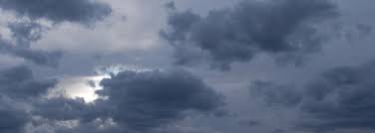

How to do the experiment on a cloudy day

By Brendan O’Donoghue,
St Columba’s College, Stranorlar, Co Donegal, Ireland

There is a way to do the experiment even if it is cloudy:

- Mark the position of the base of the vertical pole on the southern edge of a sheet of A0 or A1 paper placed on flat, horizontal, dry ground.
- Then mark the tip of the shadow with a small dot all through the mid morning to mid afternoon, whenever the sun breaks through. The dots will form a curve.
- If you get enough data points and can get a smooth curve then the part of the curve closest to the base of the pole will be the location of the tip of the pole's shadow at true noon.
- It is a fudge, but can give accurate enough readings. At least it would dispel the immediate disappointment of no sun at EXACTLY true noon.

